Agenda
Meeting of the Concurrent Education Students’ Association Council
DATE
6:30 PM, Kinesiology 101

- Motion #1 - Adoption of the Agenda of the meeting of September 22nd, 2019
Moved by: Jazz Graham
Seconded by: Jathorsan Lingarajan
- Motion #2 - Approval of the Minutes of the meeting of September 8th, 2019
Moved by: Jazz Graham
Seconded by: Jathorsan Lingarajan
- Speaker’s Business
- President’s Report
- Vice Presidents’ Reports
  - Vice President (Internal)
  - Vice President (External)
- Executive Administrator’s Report
- Treasurer’s Report
- Events Director’s Report
- Marketing and Design Director’s Report
- Academic Affairs Commissioner’s Report
- Equity Affairs Commissioner’s Report
- Sustainability Commissioner’s Report
- Senator’s Report
- AMS Representative’s Report
- Year Representatives’ Reports
  - First Year Representatives
  - Second Year Representatives
  - Third Year Representatives
  - Fourth Year Representatives
- BISC Representatives’ Report
- QCE Chair’s Report
- Head Teach’s Report
- Statements by Members
- Question Period
- Old Business
- New Business
- Discussion Period
  - President’s Hiring
- Speaker’s Last Word
- Adjournment
President’s Report

Vice President (Internal)’s Report
Makenzi Mellon

Orientation Week

Orientation Week went very well and we are so proud of Teach Exec and all the teaches for their hard work in welcoming the first years to Con-Ed and Queen’s. We would like to thank you the ASUS exec team for speaking at our Welcome Forum and speaking on behalf of ASUS to the incoming class. CESA Exec made a conscious effort to be present and visible at as many events as possible during the week. We thoroughly enjoyed experiencing Orientation Week through a different lens and helping out Teach Exec in any way we could.

Coming Up

A major event coming up in Con-Ed is Con-Ed Camp! It is a weekend getaway for Con-Ed students of all years full of fun team building activities and Con-Ed traditions. We have just hit above 80% of our capacity for registration which is very exciting. CESA Fall elections will be on October 1st and 2nd. We additionally just released our fall hiring applications and interviews occurring next week! If you have any questions about anything in my report or anything Con-Ed related, feel free to email me at vpinternal@cesa.queensu.ca.

Vice President (External)’s Report
Jathorsan Lingarajan

Events Portfolio
- Great job to the Social Affairs coordinators who planned a very successful social last week! Stay tuned for more social affairs events.
- Another round of applause to the Community Affairs Coordinators for running a great Pancake breakfasts. My stomach is so full.
- The events card is a new initiative created by the social affairs coordinators which aims to increase attendance at all CESA events.
- I hear the Fall Workshops are in the works.

QCE 2020
- The girls are phenomenal! Things are progressing in the QCE World! Stay tuned for more information.
- THE VESTS ARE IN!

Student Choice Initiative
- Students are working very hard to make events accessible, fun, diverse and engaging for the 1145 students in Con-Ed. This may not happen if we end up losing 100s of dollars every day. Please keep that in mind.

Retreat 2019
- Thank you for filling out the survey!
- Please check your emails for the itinerary for the retreat. Please complete the payment process by Wednesday. Any questions, please let me know.

XOXO,
Jathorsan Lingarajan

Executive Administrator’s Report
Jazz Graham

Hiring
- Hiring has been pushed back and interviews are now happening in the first week of October

Office
- A lot of things are happening in the office this upcoming week- please remember to check the ipad/facebook group for procedures and that everything must go through the ipad.
- Remember it’s okay to ask for help if you are unsure how to process something- just shoot myself or one of the other executives a text.
- Campaigning period is happening right now so please remember to be extra VIP in the office, aka no campaigning in there :)

Other
- If you have an event form, remember that the need to be sent in at least 3 weeks before if you need a room, marketing, or bursaries.
  - Special thanks to those of you that have been doing so!!
- Reminder that reports need to be in by midnight the Thursday before a meeting!

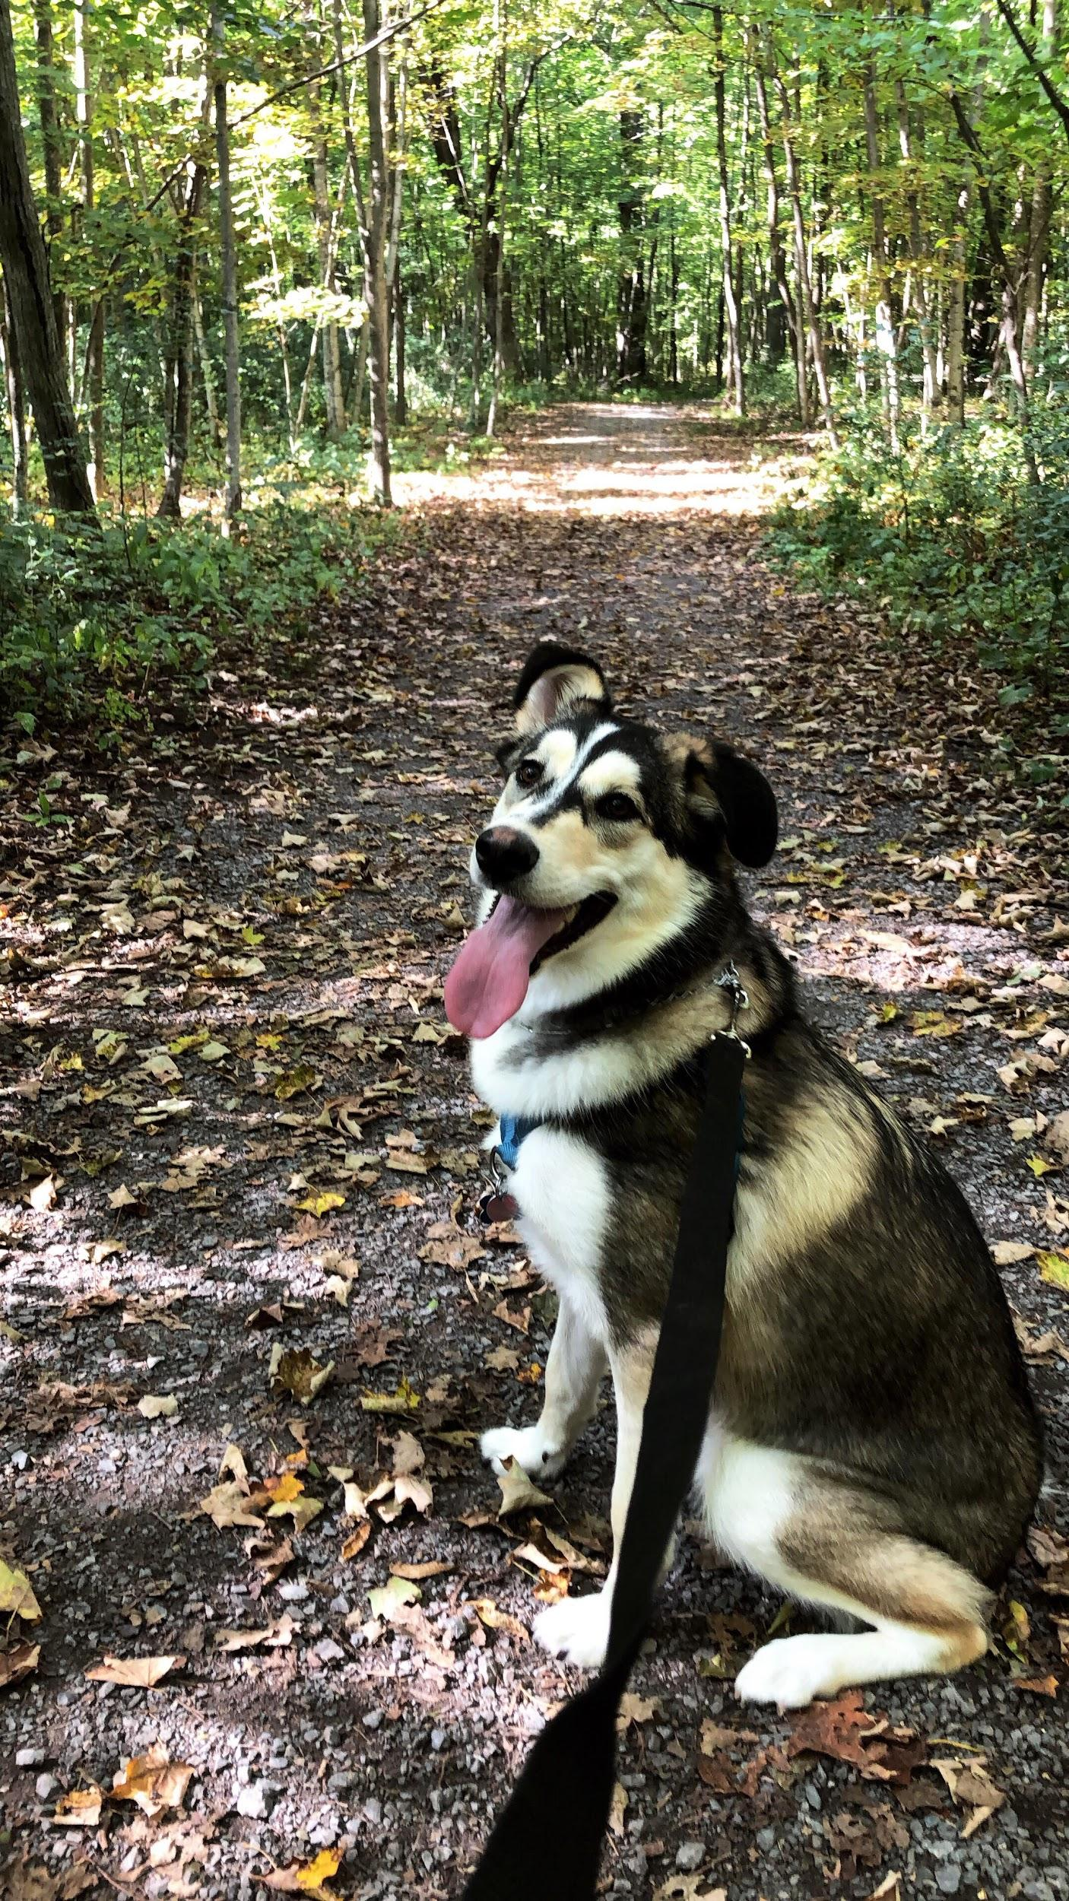
Please remember that I am here for all of you if you need anything whatsoever, nothing you may need is too big or too small.

xox Jazz

Treasurer’s Report
Alex Lauzon

HAPPY WEEK (?) MID SEPTEMBER!
Treasurer updates:
- NEW Treasurer Mailbox
- Money tracking going well -lots of spreadsheets
- I now know most of the names of the people who work at TD
Money so far:
- PLEASE PUT ALL PURCHASES THROUGH THE SQUARE APP
- Reminder to contact me as soon as possible if you need a payment done by me
- Contact me or your umbrella head at any time for an update on your spending/income

Remember to keep your receipts,
$Alex Lauzon

Events Director’s Report
Samantha Mahoney

Marketing and Design Director’s Report
Esther Eisen

Hi everyone!
I hope you’ve all been enjoying your classes!
Marketing and Design
- STICKERS!!!!!!!!
o I am so excited to say that I got to design stickers that will be sold very soon! We will be bringing back some of the old ones and adding some new ones, including frosh group stickers!

Photographers
- The pictures from O-Week are being uploaded to Facebook as fast as possible.
o Please be patient because it takes awhile to watermark and upload all the pictures
- Currently working on:
o Bringing back Shout Out Sundays on Instagram!
o Starting Throwback Thursdays on Instagram!
o A headshot event in early October!
o A possible Con-Ed Yearbook!

IT Admin
- Nothing new to report!

Lots of Con-Ed Love,
Esther
Academic Affairs Commissioner’s Report
Alex Hemmerich

· Buddy Picnic Occurred last Saturday
o Was basically rain free!
· Have started organizing Con-Ed Psych Midterm study session
o Will be taking place on October 3rd from 6-9 p.m.
o Location is still TBD
o Currently have enough volunteers but more are always welcome
· Future Alex will have attended two Learning Resource Fairs on the 19th and the 23rd to represent Con-Ed but Present Alex has not
o Present Alex hopes there’s free food for Future Alex to enjoy

Irrelevant Calvin and Hobbes comic I like:
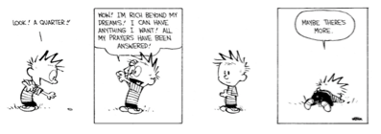
Equity Affairs Commissioner’s Report
Sarah Bentley

The bursary applications have closed for Con-Ed camp so I will be meeting this week with Makenzi and Alex and distributing the bursaries and sending out emails. Please come visit me at my office hours because I get quite lonely.

Sustainability Commissioner’s Report

Senator’s Report
Alexander Kotsopoulos

Next Senate Meeting: October 1, 2019
Alexander’s Official MCU Ranking So Far
(or until he changes his mind again...it happens like all the time lol)
- CA: The Winter Soldier
- Avengers: Endgame
- Avengers: Infinity War
- CA: Civil War
- The Avengers
- Thor: Ragnarok
- Black Panther
- Guardians of the Galaxy
- Spider-man: FFH
- Spider-man: Homecoming
- Iron Man
- CA: The First Avenger
- Doctor Strange
- Captain Marvel
- Guardians of the Galaxy vol 2
- Avengers: Age of Ultron
- Ant-Man
- Thor
- Ant-Man and the Wasp
- Iron Man 2
- Iron Man 3
- Incredible Hulk
- Thor: The Dark World

I forgot to find a meme 😭😭😭

AMS Representative Report
Julia Bukala

Hello hello everyone,
The first AMS meeting occurred this past week and it was LOOOOONNNNNGGGGG (a lot of motions, presentations, and discussions). I would like to give a big shout out to Maddie da Silva for proxying for J-Thor and being my buddy for the assembly.
Fun fact: A group of ferrets is called a business.

Best,
Julia Bukala

First Year Representatives’ Report

Second Year Representatives’ Report
Brendan Lerant & Grace Vidad

1. Con-Ed Mentorship
a. Buddy Picnic 2019 was an overall success!
b. Emails will be sent out shortly regarding commitments pairings must finish by the end of the year/semester
c. Website for mentorship was edited and at this point, only upper year students may register for a mentor and upper year registration is completely closed
d. We will create a folder where students can upload or share pics with their buddies, as we really don’t want pictures to be emailed to us 24/7
e. We went over our budget so hopefully, the fundraisers will make that back
2. Planning Event with 1st Year Reps
a. WhO aRe ThE fIrSt YeAr RePs? WE DON’T KNOW YET
b. The goal is to have a joint event to guide the first-year representatives on how to run an event for CESA and what the expectations are
c. Theme and activities of the event still TBD and that will be decided with the first-year reps (once we find out who they are ooooooh)
3. Bottle Drive
a. Bin?
b. Email us if you have empties and we’ll try to pick them up or have them all in one area
c. Trying to get a communal bin/dumpster for empties for CESA during Homecoming 2019
4. Tik Tok
a. Grace makes fire Tik Toks
5. Time we actually submitted this report to Jazz: 1:10am on Friday (sorry Jazz)

Third Year Representatives’ Report
Karina Le Chatton & Katie Mulvihill

Oh, hey there!!!!!!!!

The Welcome Back BBQ was a huge success!! Thank you to all the 3rd and 4th years who came out to celebrate the new school year with us! We had SO MUCH fun!!

We are also in the early stages of thinking about our next year event… more details to come soon.

Finally, we are planning on making a Con-Ed Clothing Committee to get input on what the faculty wants to see with clothing this year. More details to come on this as well.

Lots of Con-Ed Love,

Karina & Katie

Fourth Year Representatives’ Report
Amanda Proulx & Saoirse Kilkenny-Beattie

Hey :)
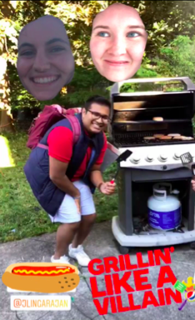
We just wanted to say thank you to everyone who came out to our BBQ last weekend! We had a great turn out and it was nice to see both new and familiar faces! A special shout out also goes to everyone who helped us grill and troubleshoot the BBQ when it stopped working.

As of now we are just brainstorming ideas for our next event, stay tuned!!!

PEACE and LUV,

Amanda and Saoirse <3

BISC Representatives’ Report
Hannah Bryon & Victoria Jonasson

Hey Everyone!!

· Getting BISC 100 & 101 to be programed to as the pre req on solus
· We will be sending emails about events happening with CESA
Good things coming in this semester!
· EVENTS!!
· Planning an event to get all the BISC students together.
Cheers,

Vic & Hannah

QCE Chair’s Report
Sandie Tran

Currently in the process of planning.
Nothing further to add.
Head Teach’s Report
Madison Berrisford

Old Business

New Business

