Agenda
Meeting of the Concurrent Education Students’ Association Council
October 6th 2019
6:30 PM, Dunning 12

- Motion #1 - Adoption of the Agenda of the meeting of October 6th, 2019
Moved by: Jazz Graham
Seconded by: Julia Anderson
- Motion #2 - Approval of the Minutes of the meeting of September 22nd, 2019
Moved by: Jazz Graham
Seconded by: Julia Anderson
- Speaker’s Business
- President’s Report
- Vice Presidents’ Reports
  - Vice President (Internal)
  - Vice President (External)
- Executive Administrator’s Report
- Treasurer’s Report
- Events Director’s Report
- Marketing and Design Director’s Report
- Academic Affairs Commissioner’s Report
- Equity Affairs Commissioner’s Report
- Sustainability Commissioner’s Report
- Senator’s Report
- AMS Representative’s Report
- Year Representatives’ Reports
  - First Year Representatives
  - Second Year Representatives
  - Third Year Representatives
  - Fourth Year Representatives
- BISC Representatives’ Report
- QCE Chair’s Report
- Head Teach’s Report
- Statements by Members
- Question Period
- Old Business
- New Business
  - Motion #3: 1st Year Rep to the AMS Appointment
Moved by: Julia Bukala
Seconded by: Julia Anderson
That CESA Council appoint one student of the association to the
position of 1st Year Representative to the AMS.
  - Motion #4: Two Members to Sit on Teach Exec Hiring Appointment
Moved by: Julia Anderson
Seconded by: Jathorsan Lingarajan
That CESA Council appoint two students of the association to sit on the
panel for Teach Hiring.
  - Motion #5: Uh Oh, We Need a Job Description
Moved by: Hanna Byron
Seconded by: Victoria Jonasson
That CESA Council amends Article 4 of the Job Description Policy as
outlined in Appendix: Uh Oh, We Need a Job Description.
  - Motion #6: A Substitution on Teach Exec Hiring Panel
Moved by: Julia Bukala
Seconded by: Nikki Li
That CESA Council make a one time amendment to Article 4 of the
Hiring Policy outline in Appendix: A Substitution on Teach Exec Hiring
Panel.
- Discussion Period
  - BISC Hiring
  - Changes for the Future of the BISC Rep Role
- Speaker’s Last Word
- Adjournment
President’s Report
Julia Anderson

Hello! My name is Julia Andersen and I am the new CESA President for the 2019-2020 year! I am in my third year and I am working towards a history major and a film minor, with teachables in history and English. I am so excited to work with council this year in the capacity of President!

I understand that council has been working hard for many months now and I hope to integrate and get up to speed on what is happening within CESA Council. I plan to work hard to smoothly transition into this role and I thank you in advance for your patience during this time. I hope to meet with council members, specifically those under my umbrella in the upcoming weeks to check in and gain a better understanding of what they have been working on.

Updates:
- the Council retreat was a huge success! Thank you to Jathorson for taking a lead on planning it and everyone who attended.
- I am so excited to introduce my intern, Kaitlyn! I am so excited to work with and get to know her this year!
- Fall hiring was a success! Thank you to all those who applied, it was lovely to get to meet you!

In the upcoming weeks I plan to work hard to transition into my new role. Thank you to all those that have helped me thus far and those that will continue to help me, I apprecaite you a lot.

I hope to make myself present in the Con-Ed Office very often in the upcoming weeks if anybody would like to meet up or chat. If you would like to arrange a meeting time, feel free to email me at 17jna@queensu.ca or tet me at 519 878 6694, until I am able to get my CESA email working.

Thank you!!!

Julia Andersen

Vice President (Internal)’s Report
Makenzi Mellon

Vice President (External)’s Report
Jathorsan Lingarajan

Events Portfolio
- There is an hoco-tie dye event on October 16th
- There is a cover the crest event also on October 16th
- Get ready for a cool and amazing Workshops Week!
- Need a fun event to go to before homecoming! Go to the Wine and Cheese event on October 18th at Mitchell Hall.

QCE 2020
- The girls are phenomenal! Things are progressing in the QCE World! Stay tuned for more information.
- QCE will commence their fundraising events very soon.
- IF YOU KNOW (actually) ANY FAMOUS PEOPLE, PLEASE TELL ME!

Student Choice Initiative
- Final opt out rate for CESA is 16%.

Retreat 2019
- Hopefully everyone had fun at the retreat!
- If you have any comments for improvements, please let me know!

Leadership Change
- Welcome Julia to the role of President. We are excited to have you part of this amazing journey.

TELC/TEAC/Faculty Board
- Renovations to Duncan MacArthur are been planned.

XOXO,
Jathorsan Lingarajan

Executive Administrator’s Report
Jazz Graham

Hiring
- Hiring will have just finished, along with elections. We are so thankful for everyone who put in such professionalism, time, and dedication in the process.
- This being said, it is still a sensitive time for applicants so please be respectful and do not speak about hiring or elections in the office.

Office
- I will be getting mail boxes in the office, hopefully, this upcoming week for some members of council who may need them.
- Will be finding out availability from new hired members this week and then updating the office schedule so please keep an eye out for that.

Other
- If you have an event form, remember that the need to be sent in at least 3 weeks before if you need a room, marketing, or bursaries.
  - Its a super busy time right now in room booking and they appreciate it when I send in earlier- this also means you can market earlier!
- Reminder that reports need to be in by midnight the Thursday before a meeting!

Please remember that I am here for all of you if you need anything whatsoever, nothing you may need is too big or too small.

xox Jazz

Treasurer’s Report
Alex Lauzon

HELLO FRIENDS!

Student choice has been finalized; I will be reviewing the budget within the next two weeks.
Nothing further to add!

Remember,
“If you don’t have enough money to buy it twice, don’t buy it at all!”
$Alex Lauzon
This is me every morning I’m so cold

Events Director’s Report
Samantha Mahoney

Nicole Li and Katie Thom:
Charity Pancake Breakfast was a super fun time! Thank you to everyone who came out to support our fundraising efforts!
Community Dinner is coming up on November 16th! We are looking for volunteers who would be able to help set-up/clean up, cook, and/or perform music at the event!
Workshops Report:
Brooke Moretti & Jenna Hamelinck:
Fall Workshops will be held from November 12th-14th! We are looking into having some great guest speakers and will be doing a lot of advertising to stay tuned and make sure to spread the word about this event!
Social Affairs Report:
Kate and Emily:
Hello everyone! We are super excited to be planning a lot of events in the next month including a homecoming tie dye station on October 16th and a Bob Ross paint night on October 30th. Keep an eye on Facebook and Instagram for more details and please share our events! Thanks!
Alumni Report:
Meganne and Nicole:

Homecoming Wine and Cheese:
· Officially sanctioned by the AMS
· Have a meeting with Faculty of Ed on Friday
· Catering/Wine Bar is ordered and confirmed
· Sign-ups are out to the Alum
· Look out for tickets in the Con-Ed office in the next week or so ($12 for open wine bar and food)

ESS Event
· B.Ed panel/event planning is in the works, just reaching out to ESS for now but stay tuned for details
· Interfaculty Event
· Reaching out to Compsa, Phe-kin etc. In the next coming months
· Talent competition (Queens’ Got Talent sort of thing)

That’s all for now!
Sam MaHOMIE 😊
Marketing and Design Director’s Report
Esther Eisen

Hi Everyone!
Marketing and Design
- The Sticker Sale was extremely successful and we made over triple of what our goal was!
- Please send event forms as far in advance as possible!

Photographers
- Shout-out Sundays have started back up again!
- Throwback Thursdays have begun and there has been an amazing response!
- Please message Allison if you want photography at your event!

IT Admin
- The website domain expired so Alex is going to renew it.

Videographers!
- I’m super excited that we have hired videographers! A lot of exciting things to come so stay tuned!

My Intern!
- I am thrilled to have hired my intern and I am so confident that they will do an amazing job, along with the other interns!

Lots of Con-Ed love,

Esther
Academic Affairs Commissioner’s Report
Alex Hemmerich

What’s been happening:
· Learning resource fairs were fun but relatively uneventful
· First Con-Ed Study Session was a huge success!
· Continuing to work on Mentorship project
That’s all! Good luck with any upcoming midterms!
Equity Affairs Commissioner’s Report
Sarah Bentley

Sustainability Commissioner’s Report
Jina Dossa

Senator’s Report
Alexander Kotsopoulos

Next Senate Meeting: October 29, 2019
Highlights from our Last Meeting
The Principal’s Town Hall Meeting
- To be held October 15, 2019 (more details to come)
- Follow up to his recent Open Letters
- All members of the University community welcome
The Impact of OSAP on Queen’s Students
- Senators were provided with a presentation on the recent cuts of the Provincial Government
- Queen’s will continue to use the federal government’s definition of dependency (meaning four years after high school)
- University’s Response
- Principal’s Response
Establishment of a Graduate College
- Expansion of the Queen’s graduate program and the creation of a College
- Long Term Plan (no dates or concrete information yet)
Mental Health on Campus
- Provost avoided direct questions on the topic, referred to the AMS’ “Empower Me” campaign
- More information on mental health will come in the coming weeks after Student Choice Initiative numbers come in
- Provost’s Response: students should go directly to professors, administration and they should come directly to him with any concerns
Policy on Sexual Violence Involving Queen’s University Students
- Provides the annual statistics of the Report
- Open Community Meeting will be held to discuss the policy; not yet organized but will be finalized soon
Student Caucus Business
The New Alcohol Policy
- AMS and SGPS taking the student lead at the moment
- Student Caucus open to bringing the issue to Senate in the near future
- We will continue to track the policy as it is developed
- If you have any thoughts or concerns please contact me
Fall Term Break
- University can pick up option to extend three year pilot project to a fourth year
- Student Caucus considering putting forward an action to restrict this and offer alternatives
- We are looking for feedback and ideas prior to bringing an action to the Senate
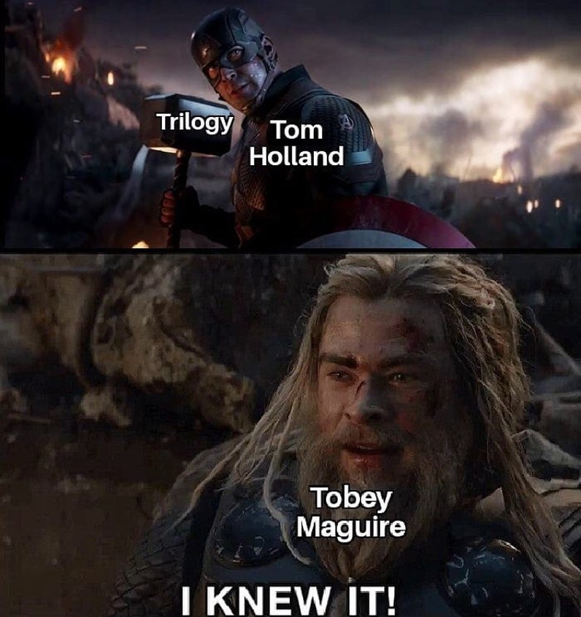

AMS Representative Report
Julia Bukala

Nothing new to report this week. Hope midterms are treating everyone well (WE CAN DO IT)!!!

Fun fact: Baby porcupines are known as porcupettes.

First Year Representatives’ Report
Hanna Slowikowska & Avery Desrosiers

Second Year Representatives’ Report
Brendan Lerant & Grace Vidad

So we forgot about the deadline again oops
· So we’re talking with the 1st year reps, Avery and Hanna (CONGRATS) to get them transitioned and we’re also hoping to make a joint event
· Emails are now biweekly
· We need to bring the empties to the Beer Store eventually

Third Year Representatives’ Report
Karina Le Chatton & Katie Mulvihill

Hellllllooooo everyone!!

By the time you read this we’ll be back from the CESA retreat! We already know that is was SO MUCH FUN WOOHOOO!!

We also had the greatest time ever at camp last weekend, best event of the year<3

We had a meeting with Makenzi on Saturday about clothing so we will have more concrete information will finally be coming this week. We want to start planning ASAP!

Nothing else going on for us right now!!

We luv uuuuuu (and we know u luv us;))

Xoxo 3rd year reps
Fourth Year Representatives’ Report
Amanda Proulx & Saoirse Kilkenny-Beattie

Hey! J

Nothing to report really! Just working on
planning our Halloween event so stay tuned!!!!

Peace & Luv,
Amanda and Saoirse

BISC Representatives’ Report
Hannah Bryon & Victoria Jonasson

Hey Everyone!!

· First event planned on the 17^{th!:} Con-Ed & the Castle! FAQ and Info night! An information, FAQ, and discussion night for Con-Ed students who have studied at the BISC, are interested in studying at the BISC, or just want to learn more about the Castle in general!

Cheers,

Vic & Hannah

QCE Chair’s Report
Sandie Tran

Head Teach’s Report
Madison Berrisford

Old Business

New Business

Appendix: Uh Oh, We Need A Job Description
From the Job Description Policy

4.21 Duties of the BISC Representatives

4.21.01 The BISC Representatives shall:
- Be non-voting members of Council and are required to attend all Council meetings,
- Be a position held by two (2) members of the Association who attended the Castle,
- Report to the Vice President (Internal),
- Update returning Con-Ed BISC students on upcoming events and information discussed at meetings of the Council,
- Be an active voice for all returning Con-Ed BISC students,
- Act as a mentor to returning Con-Ed BISC students as they transition to Queen’s main campus, and integrate into their respective year,
- Inform returning Con-Ed BISC students about academic and student life experience resources
- Host at least one (1) Con-Ed BISC event per semester, which shall cater to diverse social interests,

Appendix: A Substitution on the Teach Exec Hiring
From the Hiring Policy Manual

Be it resolved that CESA council make a one-time change, per circumstance, that on the teach exec hiring panel the spot held by the president be changed to a vice-president. Ensuring that only one member of outgoing teach exec sits on the panel.

